2020 APS Office of International Programs (OIP) Extension/Outreach Photography Competition

APPLICATION FORM
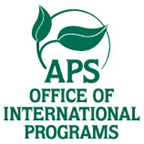
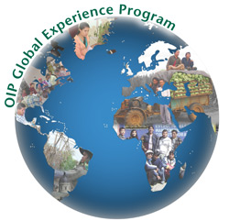
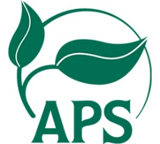

Contributor's name:
Contributor's affiliation
Contributor's City, Region, Country
Contributor's e-mail
Photographer's name (if other than Contributor)
Select whether you provide either a copyright transfer or a statement of public domain to APS as per APS Standard Photo Policy
☐By selecting this, you agree to the copyright transfer notice below.
☐By selecting this, you agree to the public domain notice below.

Image name/title:
Location where picture/image was taken (city, country):
Approximate date when picture was taken (MM/DD/YYYY):
Brief description (1 or 2 sentences) about the picture *

An email should be sent to: GlobalphotosOIP@apsnet.org and should contain one picture submission (up to 10MB in size) and the information requested above.
APS Standard Photo Policy
Digital images should be good quality and high resolution .jpg or .tif files (preferably at least 300 dpi at a size of 3 × 4 in / 7.5 x 10 cm).Submitting an image to APS OIP requires that you provide either a copyright transfer or a statement of public domain to APS. Please select one of these options below. The image you are submitting is intended for use by the plant pathology community through accessing the APS Image Database. APS will discourage any distribution and use other than provided by the Terms of Use of the APS Image Database. These terms of use are subject to change based on APS policy. For more information on APS’s position and policy on copyright, see this article: "Images in the Digital World: Why APS Copyrights the Images It Publishes,” by C. Lee Campbell.
Copyright Transfer
I confirm that I am the current copyright owner of the image described above and hereby transfer and assign to The American Phytopathological Society (APS) all copyrights in and to the image in all forms and media. Such transfer gives APS sole authority to grant rights for the image's use by others. I understand that, as the image's contributor/photographer and original copyright owner, I remain free to use the image in connection with my own publications or work without obtaining written permission from APS. I also confirm that publication of the image by APS will in no way violate any copyright or other personal or proprietary right of any person or entity. I acknowledge that APS is relying on the statement above in claiming copyright to the work.
Public Domain Notice
I hereby confirm that the image described above, having been created by an employee or agency of the U.S. government or for some other reason not being eligible for copyright, is in the "public domain" and, as such, may be reproduced freely. I acknowledge that The American Phytopathological Society is relying on the statement above in determining that the work is copyright-free.

