



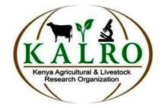
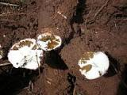
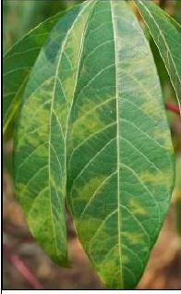

2015 APS-OIP Global Experience Award Report

Strengthening field diagnosis of cassava virus diseases, development, testing and publication of an undergraduate-level teaching resource on cassava brown streak disease in East Africa

2015-2016
Workshop Summary
The 2015 Cassava mosaic (CMD) and cassava brown streak (CBSD) diseases, field diagnostic workshop was held on June 4th and 5th 2015 at the Akuranut Hall, Adungosi, Teso County in Kenya. It was hosted by the Root and Tuber Crops Program - Kenya Agriculture and Livestock Organization KALRO (Non Ruminant Research Institute, Food Crops Research Centre) Kakamega, and the APS-Office of International Programs 2015 Global Experience Award. Additional funds were provided by the Donald Danforth Plant Science Center Funds and brochures, posters and material used in the workshop were provided by IITA. The aims of the workshop were to strengthen the stakeholders (extension officers, researchers and practitioners) knowledge of the two diseases (CMD and CBSD), strengthen their field diagnostic ability for CBSD, to improve the participants’ capacity to train others, and to develop an educational extension brochure to assist with this. Participants were predominantly extension workers from the cassava growing counties of Busia, Kakamega, Teso and Siaya. The workshop was conducted over two days and included a pre- and post workshop evaluation on participants knowledge of the diseases, an overview of the diseases, leaf and root diagnostics of CBSD and the first day ended with a field trip to KALRO- Alupe in Busia. Prior to the workshop 40 % of participants considered CBSD a bacterial disease and were unable to visually distinguish foliar symptoms of CBSD from CMD. At the end of the workshop 100% considered CBSD a viral disease, while 64% of participants said the workshop had provided them with new information on CBSD. Impact assessment was done in June, 2016, it showed 92% of participant’s utilized information from the workshop.

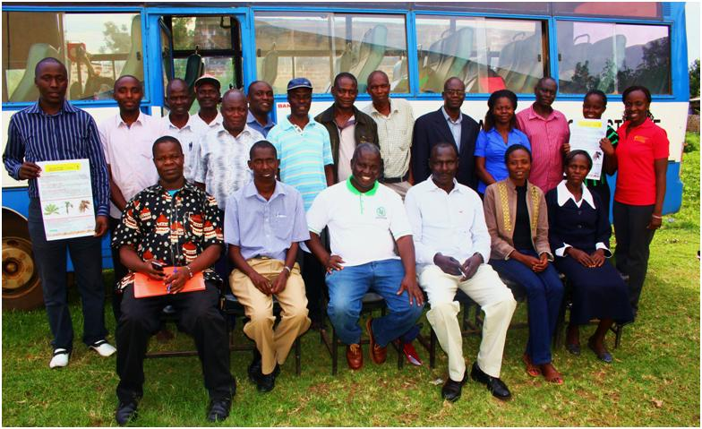
Figure 1. Group Photo of Participants and trainers at the CBSD workshop in June 2015 held at Teso County in Western Kenya

CBSD Case Study Development – Summary
In addition to the workshop, a student centered, active learning teaching resource was developed (case study). It is intended to inform and educate students on CBSD diagnostics, management and impact on affected communities. The case study is set in an African village with several characters including, growers, extension workers, researchers, and study abroad students. The case utilized videos, group discussions and role playing during presentations. The case study was tested in May and June of 2015 in four universities in East Africa: Makerere University, Kampala, Uganda (26), Chuka University, Meru, Kenya (14), Kenyatta University (63) and University of Nairobi (30) in Nairobi Kenya. Locations of the Universities in East Africa are shown on the map in Figure 2. The case study was presented and tested with students of plant pathology, agricultural education, field crops management and virology. More than 90% of students appreciated the real world scenario approach to the exercise. After testing the case was modified to incorporate new perspectives gained and suggestions from participants and submitted for publication in August 2016. This resource has been accepted for publication in the Plant health instructor an online open-access education journal.

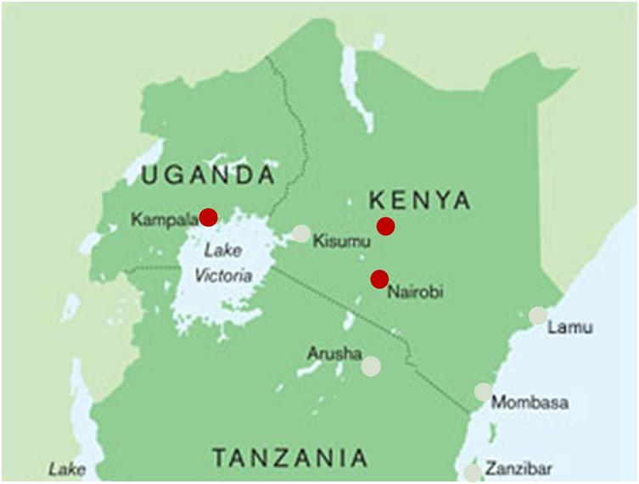

Figure 2. Location in East Africa of cities where Universities that participated in testing of CBSD case study are located Kampala, Meru and Nairobi (Red dots)
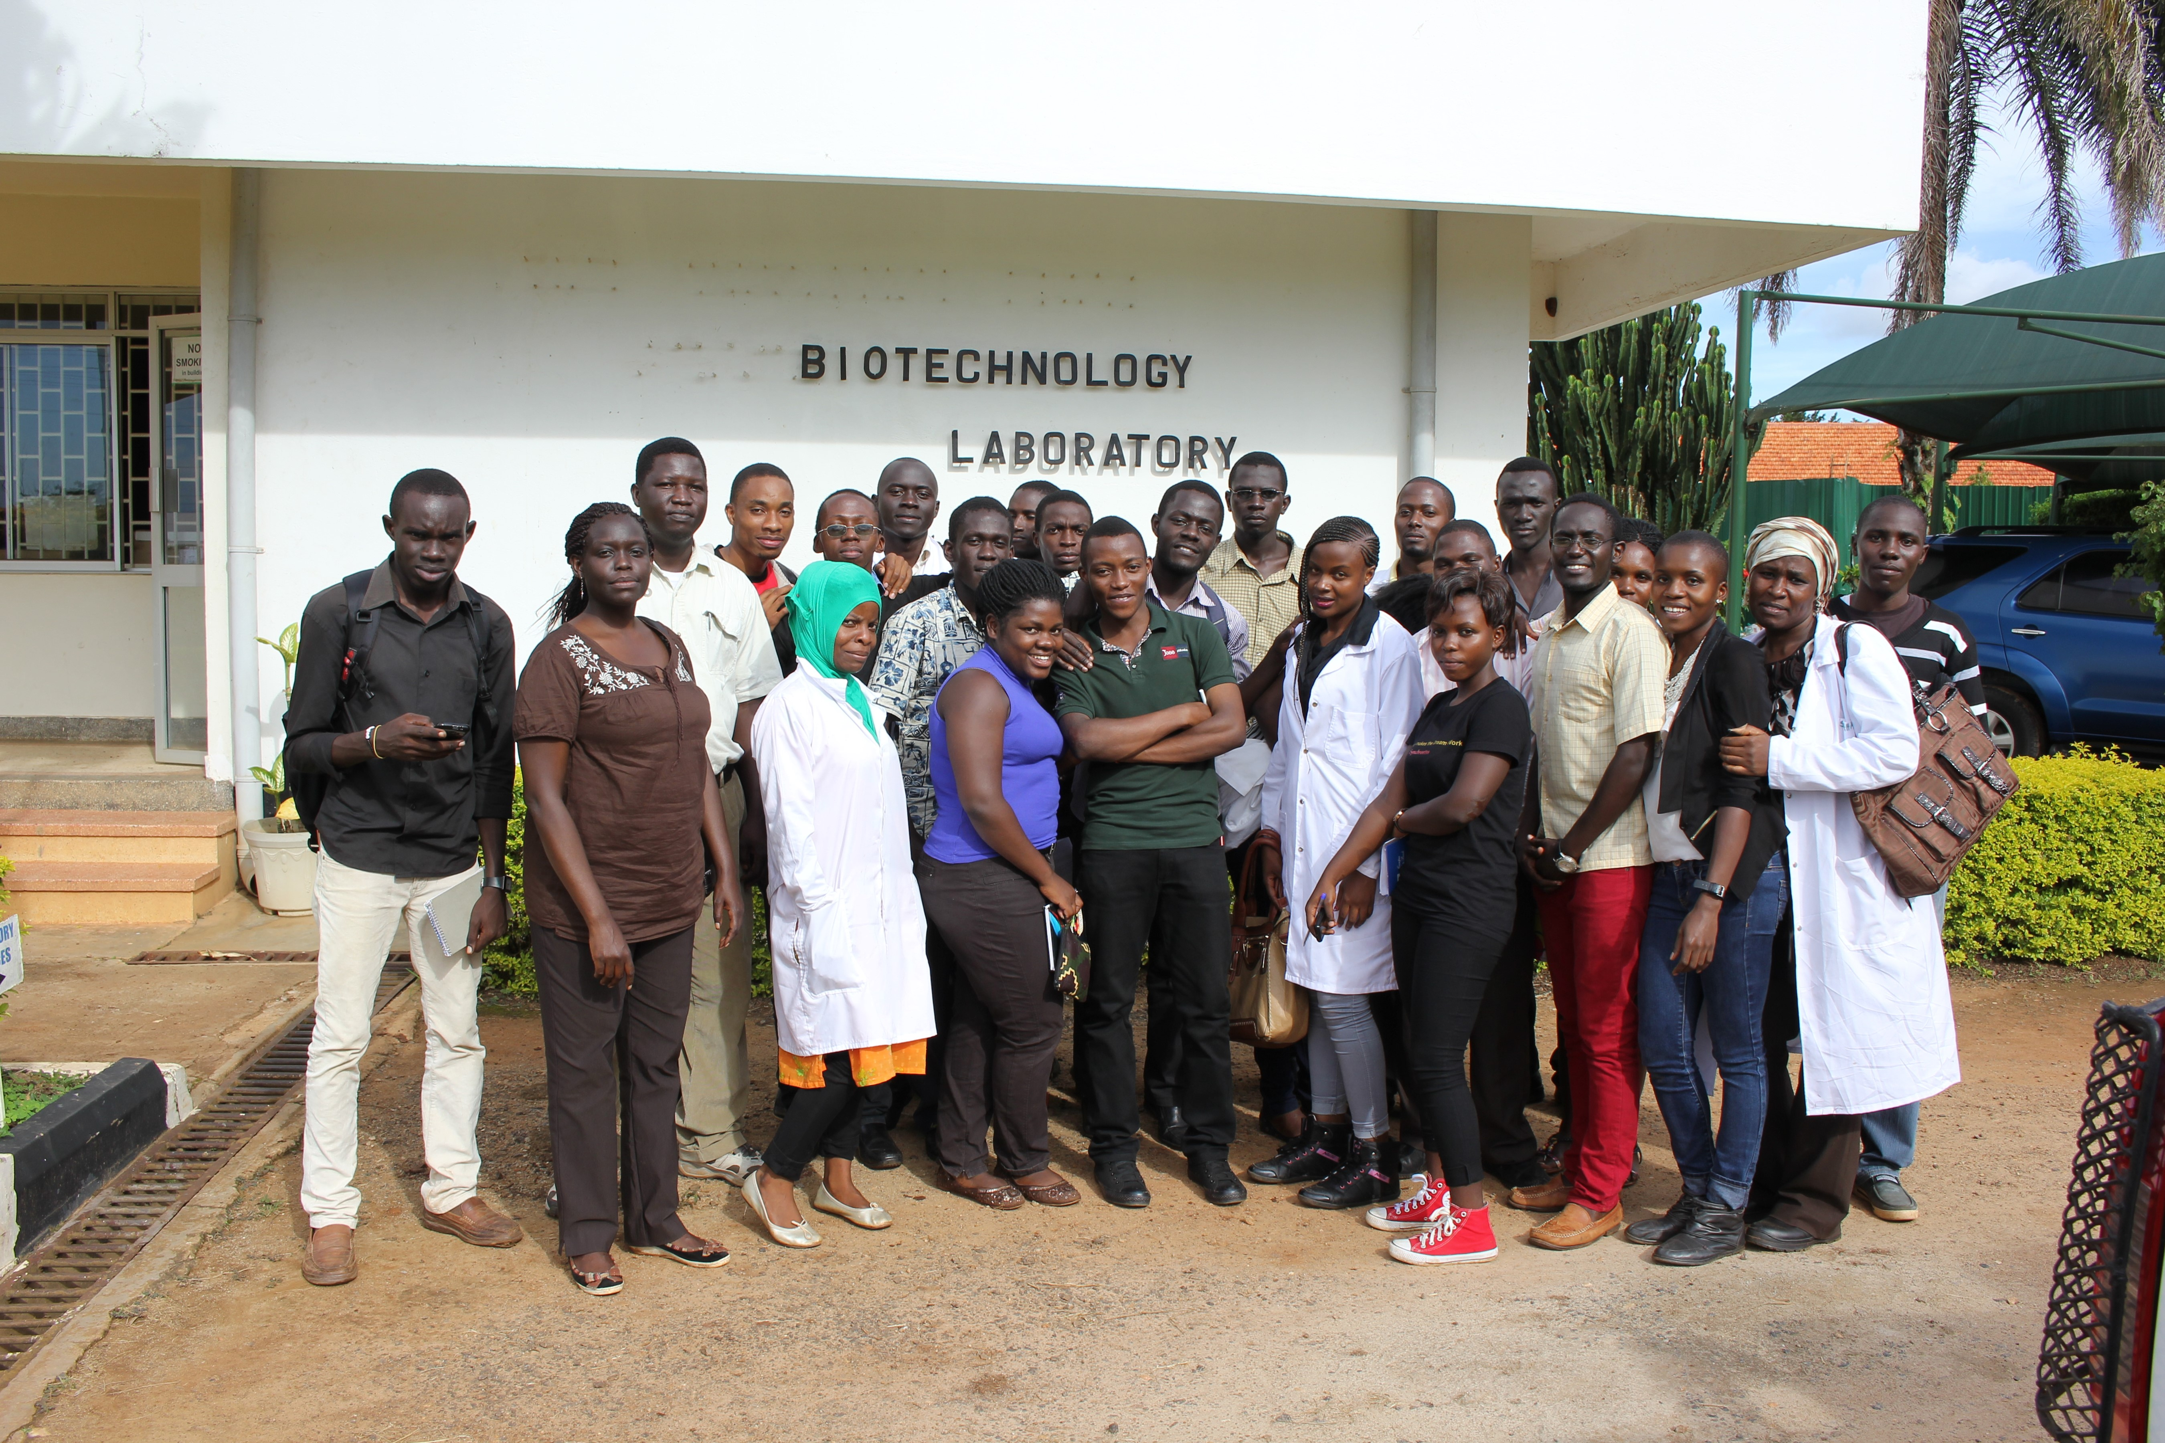

Figure 3A: Makerere University, Plant Pathology Students during their field trip to the National cassava root crops research institute (NACCRI) Namulonge, Uganda 05/05/15
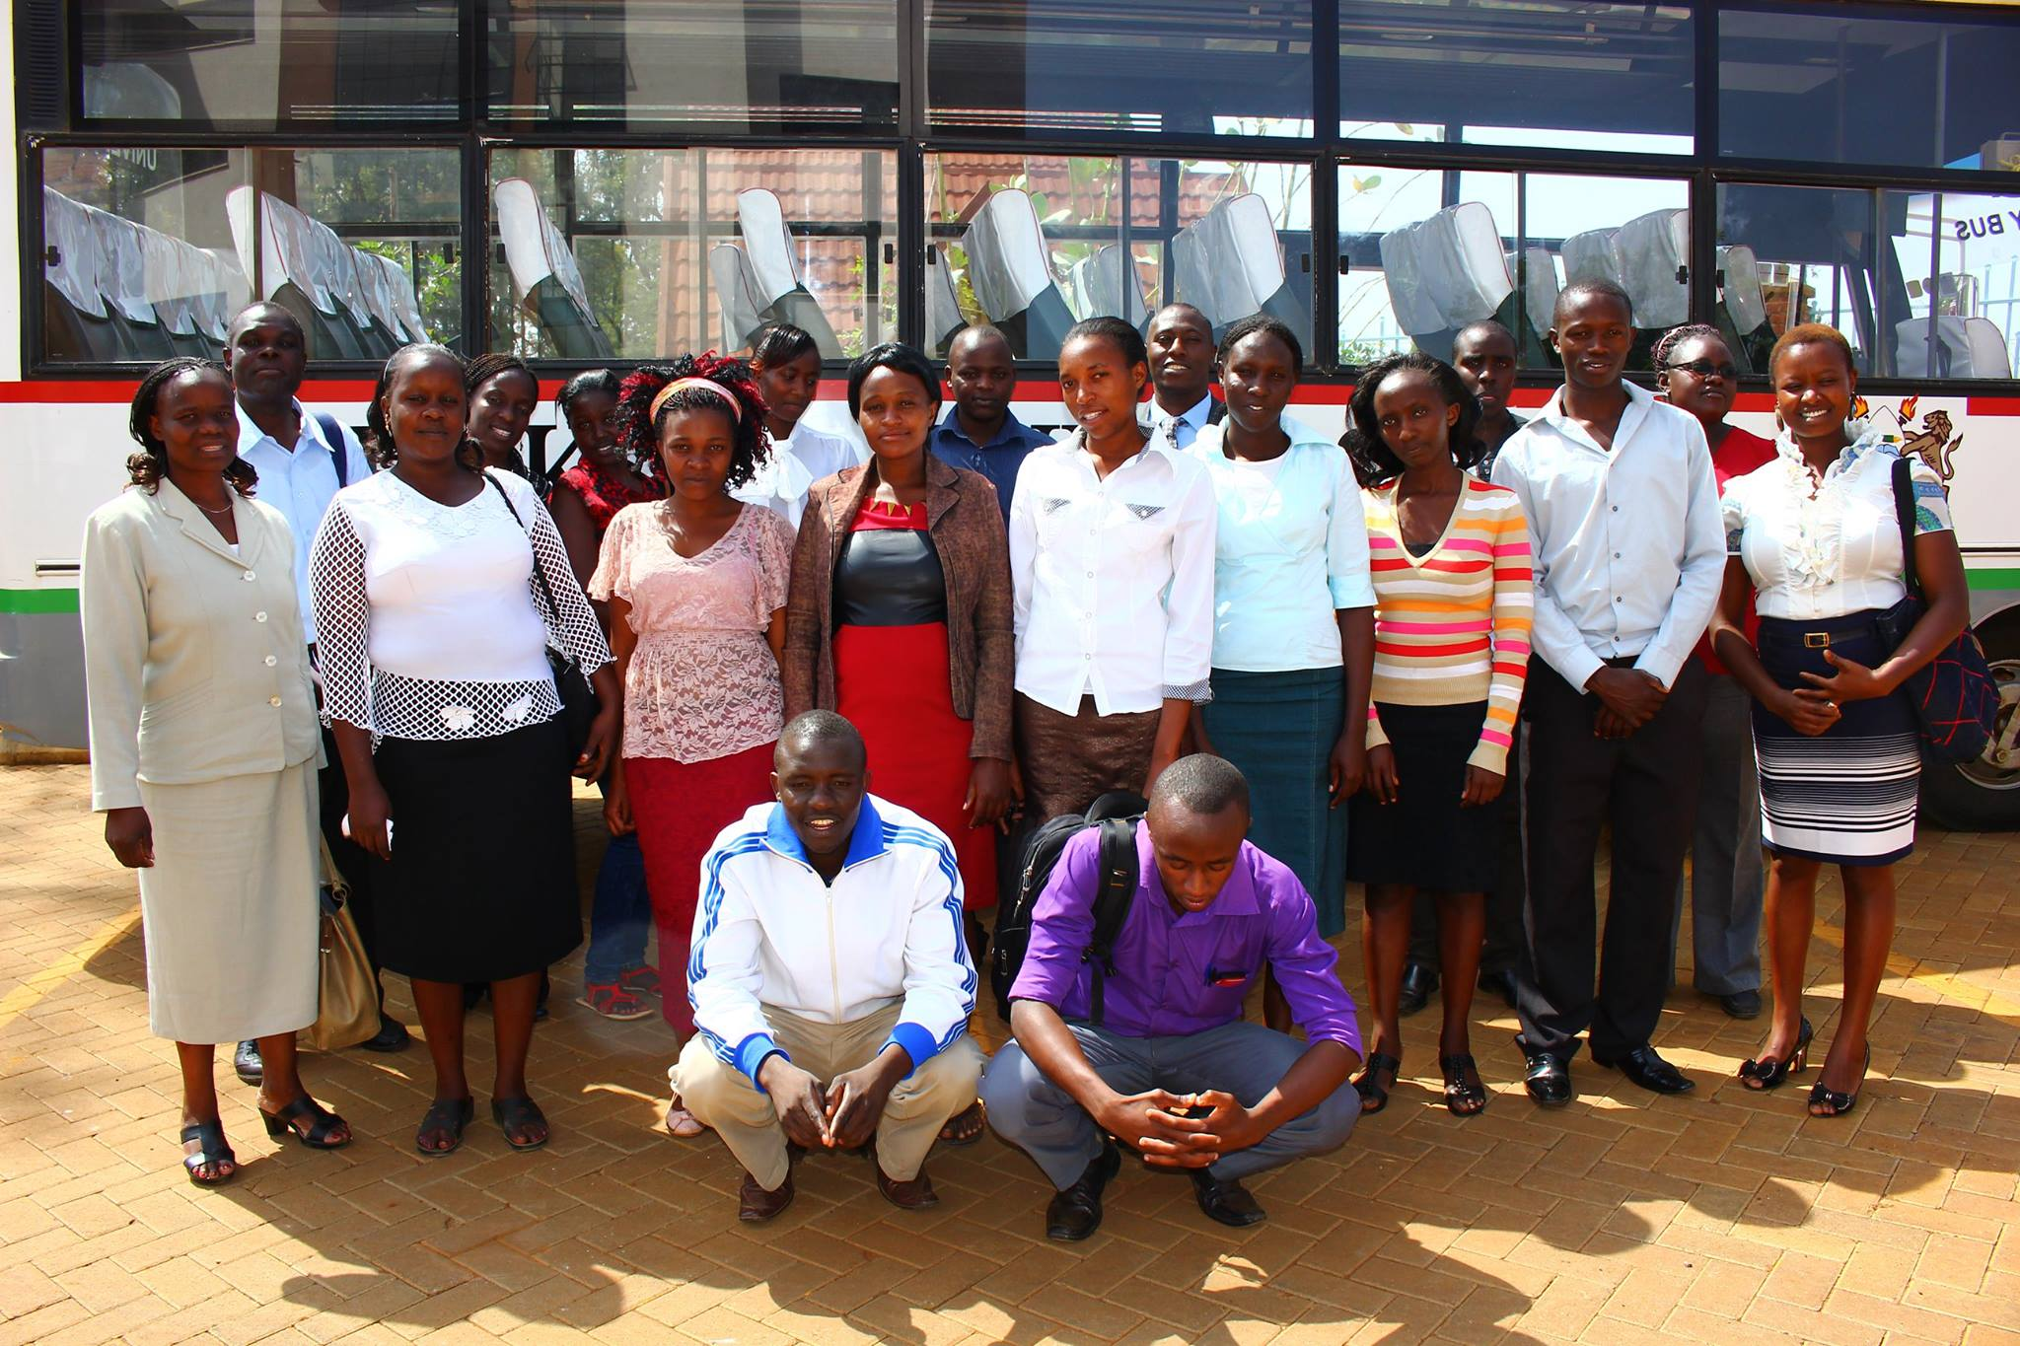

Figure 3B: Group Photo of Chuka University Agricultural Education students and case study instructors after the exercise at Meru, Kenya) 06/15/15
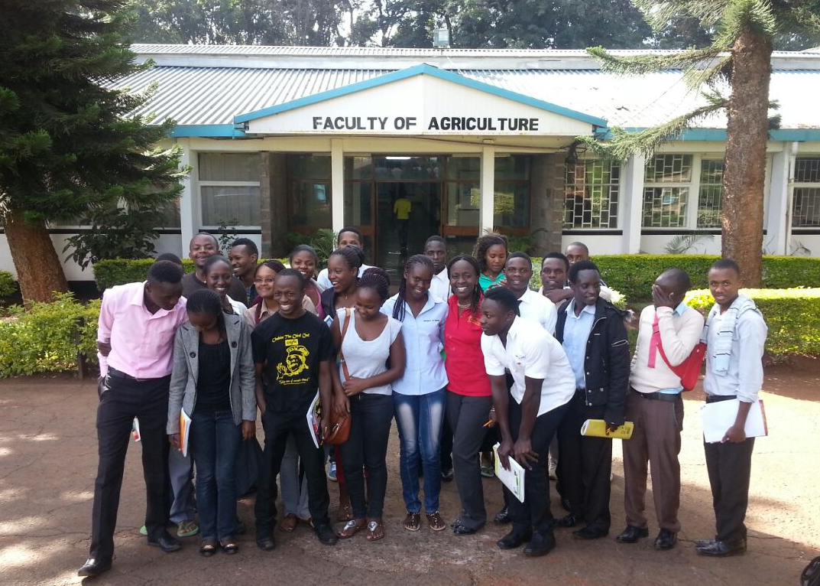

Figure 3C: Group Photo of University of Nairobi Virology students and case study instructors after the exercise at Kabete, Nairobi, Kenya, 06/26/15
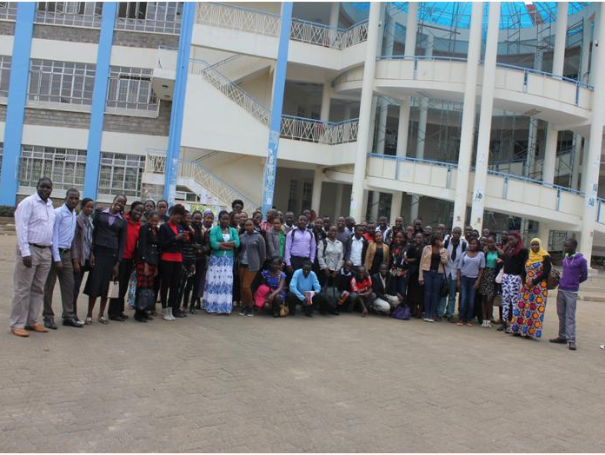

Figure 3D: Group Photo of Kenyatta University Field Crops Management students and case study instructors after the exercise at Juja, Nairobi, Kenya, 06/20/15
Importance of Cassava
Cassava is an important food security crop; grown on over 10,800,000 ha in Africa (FAOSTAT, 2014). NEPAD named cassava as its crop of choice to fight poverty in Africa. Cassava mosaic disease (CMD) has been a major constraint in cassava producing areas since the 1890’s (Thresh et al., 1994). However in the last two decades, CMD has severely constrained cassava production in East Africa (Legg et al., 2011). Due to cassava’s importance, a multi-tiered effort has been directed at combating the disease, involving control approaches such as: resistant varieties, phytosanitation and biotechnology (Alicai et al., 2007, Mallowa et al., 2011, Sayre et al., 2011) with a measure of success.
The current resurgence of cassava brown streak virus disease (CBSD) in East Africa has added a new dynamic to the existing biotic constraints. Tuberous roots from cassava plants affected by CMD can still be eaten. In plants severely affected by CBSD, however, tuberous roots develop a characteristic dry, brown rot, which makes them inedible. In addition some CMD-resistant varieties are susceptible to CBSD. In order to address this new CBSD problem, considerable research efforts, both in East Africa and elsewhere, are being directed towards developing sustainable control strategies for the disease. Although great progress has been made in expanding conventional and biotechnology-focused resistant development efforts, as well as strategies for clean seed production and field phytosanitation, much still remains to be done.
Justification
It is vital, however, to continue to reach out to stakeholders with extension and diagnostic tools for identification and differentiation of the two diseases and their management. Production of brochures in several local languages in addition to English was encouraged The diagnostic workshop aimed to strengthen capacity of national research programs to train stakeholders and improve the participants’ capacity to train others and develop a simplified educational brochure to be used by stakeholders.
Collaborators
Workshop: Michael Akhwale, Senior Agronomist, KALRO, Kakamega
CBSD Case Study: Dr. Shahasi Athman – Plant Pathologist, Makerere University, Kampala, Uganda; Ms. Grace Oloo, Horticulturist, Chuka University, Meru, Kenya; Dr. Douglas Miano – Virologist, Hildah Odongo – Instructor Nairobi University, Nairobi, Kenya; Dr. Nicholas Korir, Horticulturist, Kenyatta University, Nairobi, Kenya
Technical and Logistical support: Dr. Alison Robertson, Extension plant pathologist, Iowa State University, Iowa, USA; Dr. Hector Quemada – Int. Programs, Donald Danforth Plant Science Center, St Louis, USA; Mr. Hannington Obiero – Independent Cassava Consultant, Kakamega, Kenya; Ms. Sandra Ruong’o – Communication Specialist, JOOF, Nairobi, Kenya; Dr. Emmanuel Ogwok – Virologist, Namulonge, National Crops Resources Research Institute (NaCCRI), Namulonge, Uganda; Dr. James Legg, Virologist, International Institute of Tropical Agriculture (IITA), Dar es salaam, Tanzania.
Workshop and Case Study Location and Facilities
Kenya Agricultural Livestock and Research Organization, Non Ruminants Research Institute (KALRO), at Kakamega, Kenya). As a leading research center, they have laboratories, conference rooms, demonstration plots and field trials on site and in collaborating stations (Alupe) that were visited.
Makerere, Chuka, Kenyatta and Nairobi are leading universities with strong programs in Agriculture, Biotechnolgy and Science. They have smart lecture theatres fitted with projectors and sound systems to watch the assigned videos. Students from Makerere were able to go on a field trip to the National cassava root crops research institute (NACCRI) Namulonge, Uganda.
KALRO Kakamega and NACCRI Namulonge, have a mandate for cassava research in Kenya and Uganda respectively and are currently conducting a wide range of research on cassava diseases including CBSD and CMD.
Workshop Day One
The 15 participants included research, agricultural and extension officers from the ministry of agriculture and other government institutions and NGO representatives. Their clientele is largely resource-poor farmers with limited access to information. This training of trainers focused on making the information available to this clientele through training, extension visits and access to simplified English and local language brochures. Workshop was convened by Sally Mallowa, Iowa State. Instructors for the workshop Mr. Michael Akhwale (Diseases) and Mr. Ismael Njarro (Diagnostics) KALRO, Kakamega, Kenya. The field trip to KALRO, Alupe Kenya was organized by Geoffrey Mafura (Table 1)
A brief profile of each participant (Table 2), was recorded which included data on their gender, educational qualification, current job and duties, contact information and clientele as relates to CBSD. Assessment of their baseline knowledge of the two diseases was done using written questions and images of symptoms at both the beginning and end of the workshop, to review the participants’ level of comprehension and competency with diagnosis of the two diseases. About 60% of participants were aware that CBSD was a viral disease prior to the workshop; 13% were unfamiliar with root symptoms and 40% were unfamiliar (confused) about foliar symptoms. At the end of the workshop all participants were aware the disease was viral and all were able to accurately identify root and foliar symptoms of CBSD. However when compared to CMD, 40% of participants were unable to distinguish the two diseases before the workshop, compared to 12 % after the workshop. 64 % of participants ranked the workshop highly for having strengthened their knowledge of CBSD while for 46% of participants, the workshop was useful and provided new information. This is presented in the (Annex 1)

Table 1. Program for CMD and CBSD Diagnostic in Workshop Western Kenya

TIME | ACTIVITY | RESPONSIBLE PERSON
Day 1: June 4, 2015
 | Registration of participants | Root Crops Program KALRO
10:00 -10:30 am | Welcome and introductory remarks | Acting Centre Director Mr. J. Mpapale& Head of Root Crops Dr. V. Woyengo
10:30 – 11:00 am | Baseline knowledge evaluation  Overview of cassava viral diseases biology and management | - Workshop Convener
11:00 am | Tea break | - All participants
11:30 - 12:20 pm | Introduction to CMD and CBSD | - Mr Michael Akhwale
12:20-1:30 pm | Field surveillance of CMD and CBSD and Leaf & root disease diagnostics | - Mr Ismael Njarro
1.30 pm | Lunch break and group photo | - All participants
2.30 - 5:00 pm | Visit to Demonstration and Field Plots (Diagonal and Zigzag field scouting ) Discussions, Questions and comments | - Mr Mafura & Mr. Njarro
 | Day 2: June 5, 2015
8.00-10.00 am | Group Review and feedback session on brochures content. Sample presentation and tips on brochure placement | - Workshop Convener
10.00-10.30am | Knowledge evaluation and participants evaluation of workshop | - All participants
10.30-11.00 am | Vote of Thanks  Closing remarks and presentation of certificates | - Participant Reps (Mr. J. Oriama (Busia) and Mr. Mike Ndubi (Siaya)  Mr. Akhwale and Dr. Woyengo
11.00 am | Tea break | - All participants

Table 2. CMD and CBSD Field Diagnostic Workshop Participants, June 2015
- Mike Ndubi Ministry of Agriculture
- Samson Simiyu Ministry of Agriculture
- Ann Murunga Ministry of Agriculture
- Joshhua Oriama Ministry of Agriculture
- Godrick Ogola Ministry of Agriculture
- George Oduma Ministry of Agriculture
- Charles Oduor Ministry of Agriculture
- Simon Emurudu Ministry of Agriculture
- Rachel Adipo NGO
- Beatrice Abukayot NGO
- Eliud Otieno NGO
- Samson Simiyu NGO
- Diana Masika Research Institute
- Geoffrey Mafura Research Institute
- John Mpapale Research Institute
Workshop Day Two.
The participants had a lively, in-depth discussion on the disease symptoms and major distinguishing factors of the two diseases. They also discussed the management information available and analyzed existing brochures. Participants made suggestions on how to simplify this information and recommended the development of a brochure targeting growers that should highlights symptoms (leaf stem and root), effects (loss of yield). A simple CBSD presentation suggestion for growers included the question: ’ Have you ever seen this disease on your farm’ on a pictorial displaying disease symptoms. As well as simple descriptive names for identifying disease symptoms e.g.’ugonjwa wa kuozesha mihogo (Kiswahili) literal translation - cassava root rotting disease (CBSD). It was suggested that these would be easier for growers to understand than when vocabulary or scientific jargon is used. A simplified version of a CBSD brochure based on these recommendations was developed in 2016 It is currently being translated (Annex 2).

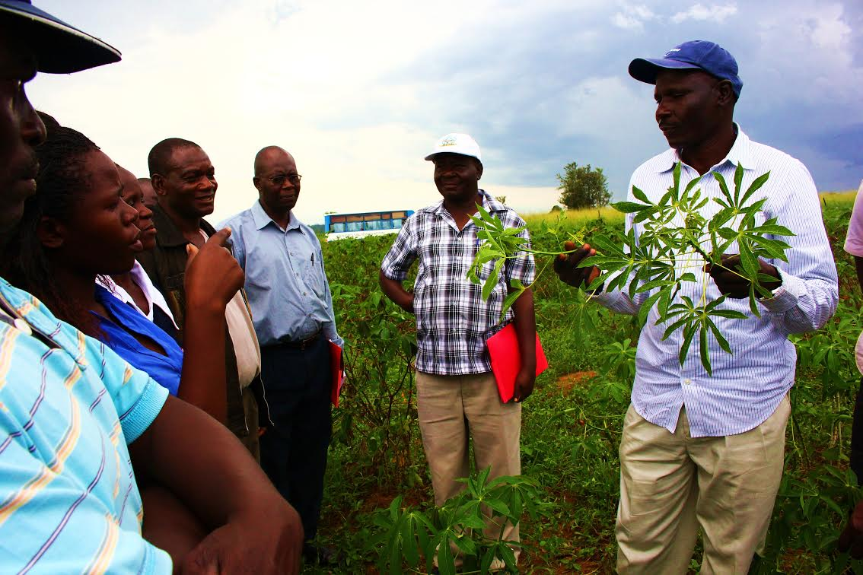

Figure 4A. Mr. Njarro pointing out foliar symptoms of CBSD to workshop participants during field trip to KALRO, Alupe, Kenya 06/04/2015
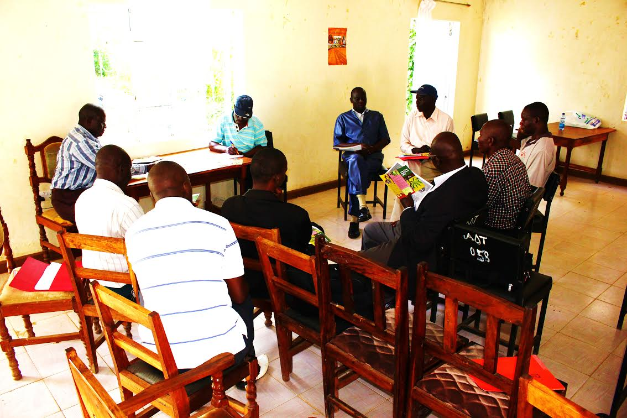

Figure 4B. Mr. Akhwale leading group discussion on developing simplified CBSD brochure during diagnostic workshop Teso, Kenya 06/05/15
Impact of the workshop
A year after the workshop, an impact assessment phone interview was conducted with 87% of workshop participants (13). All participants appreciated the workshop and stated that cassava still ranked highly in importance in their work. Participants detailed reasons for increased importance as: NGO’s encouraging farmers to grow cassava as certified planting material. Maize lethal necrosis virus is an emerging problem in the region and planting cassava as a rotation and food security crop, is recommended.
Most participants (92%) were able to utilize information gained from the workshop. 30% were able to use it in diagnostic activities differentiating CBSD from CMD, while 54 % were able to use it during trainings of farmers (46%) and other extension workers (8%).
All participants ranked their level of satisfaction with the workshop as high and declared their interest in a follow-up workshop with similar. 23 % of participants recommended the inclusion of other cassava pests and diseases in the training content. 30 % suggested the use of farmers’ fields for practical sessions instead of the research center. In terms of composition of participants 53 % recommended the inclusion of participants who were growers and leaders of youth agricultural groups. 23 % suggested two separate trainings, one training for farmers one for extension and then a joint meeting. Finally 8% of participants would like to see trainings every 3-4 years as more information and diagnostic tools become available.

Budget and budget justification item (US $)

BUDGET ITEM | APS-OIP  FUNDS | MATCHING FUNDS | TOTAL
Convener air and road fare to and within in East Africa | - | $2000 Travel award Danforth Center | $2000
Workshops training material, participants travel & associated expenses) | $2600 | Conference facilities, Demo plots and samples | $1250  (in-kind)
Development of undergraduate level resource, ($250/institution) | $1400 | Classroom, equipment and personnel (co-instructors) | $1250  (in- kind)
CMD and CBSD Local language development and brochure printing | APS
Undergraduate case study - materials and publication costs | - | Plant Pathology Dept. Iowa State ,  IITA, Tanzania | $1500  (partly in- kind)
TOTAL | $4000 |  | $6000

CBSD case study -undergraduate level teaching resource
This teaching resource was developed by Sally Mallowa, it was tested with 133 students in four universities. It acquaints students with diagnosis of CBSD, presents facts on this disease and gives principles on its management in the East African context. It was carried out in discussion style and instructors served as moderator; they focused on increasing awareness on the disease and its dissemination. They steered discussion on how the issue affects cassava growers and food security in East Africa. The resource has been accepted by the “The Plant Health Instructor”, an online journal published by the APS Education Center, where case studies have open access (Annex 3). Participating students were undergraduate students of virology, field crops, agricultural education and plant pathology. These are appropriate as the case was designed for upper level students in crop protection, IPM, plant health management, plant pathology, or sustainable agriculture courses, where students can apply previously learned information to interpreting the new knowledge. It provides an opportunity to highlight the biology of the disease, symptoms and diagnosis at field level, and sampling and surveillance methods, as well as management strategies. Once published, stakeholders in universities and research institutions in East Africa will be notified about the availability of the resource. Creating and publishing this resource for undergraduate teaching on CBSD will increase the visibility of the disease and encourage the training of students in the region and internationally on this important disease. Presentations were made at APS, California, USA in 2015, World Congress on Root and Tuber crops, China and BSPP, Oxford, UK in 2016 (Annex 4,5,6, respectively).
Cassava brown streak disease (CBSD) undergraduate case study delivery timeline (50 minutes without optional creative and laboratory exercises)

STEP | TASK | TIME (MIN.)
1. | Review grasp of assigned background information, characters and keywords | 8
2. | Reading of the case study | 5-7
3. | Small group discussions of issues arising and key points of diagnosis, preparing answers to assigned questions and developing on talking points for the “group” | 15-20
4. | A spokesperson for each group presents main points to the class | 5-7
5. | Class discussion - emphasize complexity of CBSD diagnosis | 8-10
6. | Wrap up and optional creative exercises (assignment) | 3-6
7. | Analyze students comprehension of learning objectives and critique of the exercise (By email or done at beginning of next class session) | 10
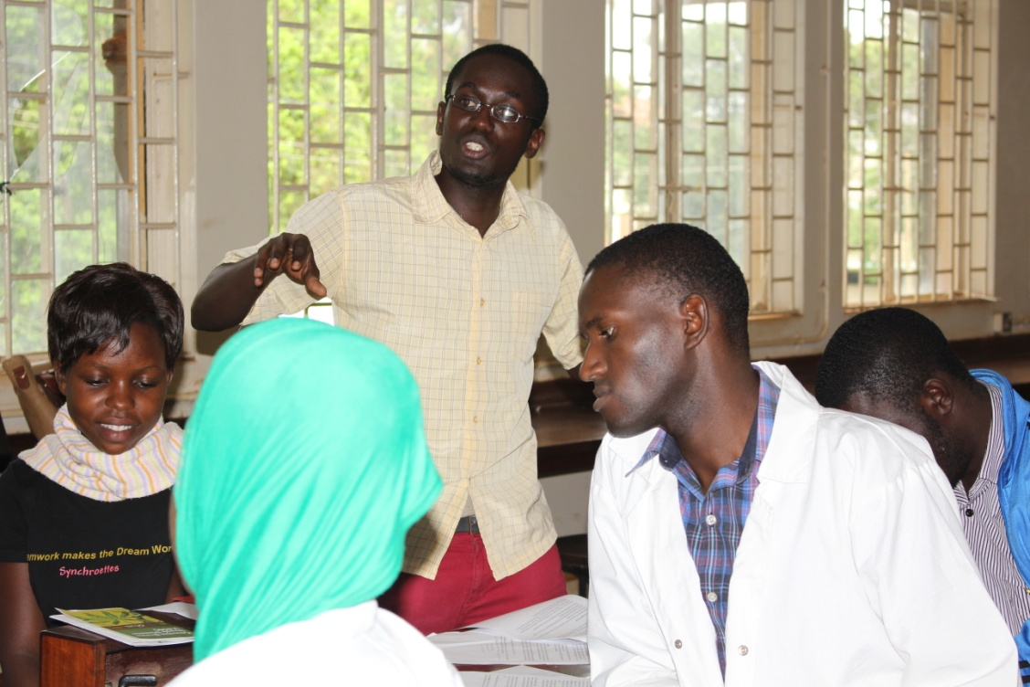

Figure 5A: Makerere University students making group presentations during case study activity in Kampala, Uganda, 05/05/15
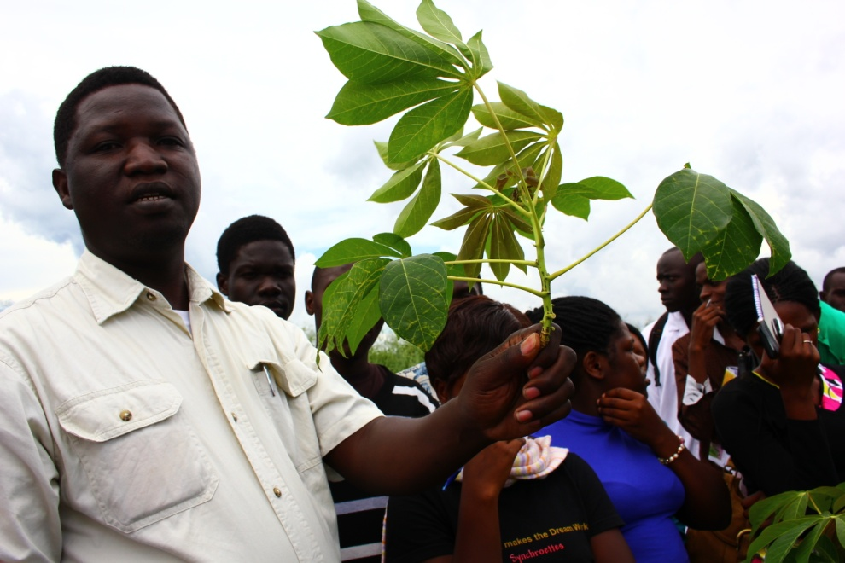

Figure 5B: Dr. Emmanuwl Ogwok pointing out CBSD foliar symptoms, to Makerere University students, during their field trip to (NACCRI) Namulonge, Uganda 05/05/15
Presentation and Awards

March 2015 - APS OIP Global Experience Award
July 2015 – Next GEN Cassava Female Scientist Travel Award
July 2015- Travel Grant Program for World Congress on Root and tuber Crops WCRTC
August 2015 – APS, California POSTER APS Annual Meeting August 2015
October 2015- Chuka, Kenya POSTER 2nd Annual University Conference
Jan 2016, GCP21, Nanning China – POSTER World Congress Root and Tuber Crops
Jan 2016, GCP21, Nanning China – ORAL World Congress Root and Tuber Crops
Sept, 2016, BSPP, Oxford, UK – ORAL British Society for Plant Pathology

- Mallowa, S. Athman, S., Ruong’o, S., Abucheli, G., Korir, N., Odongo H., Miano, D., and Robertson, A.E Rotten Inedible tubers: the case of cassava brown streak disease. Accepted for publication, Plant Health Instructor. 2017.
- Mallowa, S., Robertson, A and Fauquet C. Tools of pedagogy and global partnership contribute to war on cassava viruses. Proceedings of the British Society for Plant Pathology Meeting. Oxford, UK. Sep 12-14 2016
- Mallowa, S, Akhwale, M., Njarro, I., Obiero H., Ruong’o S., and Robertson, A. Strengthening the Capacity of Extension Workers to Diagnose Cassava Brown Streak Disease in Western Kenya. Ed. C.M. Fauquet, Electronic Proceedings of the First World Congress on Root and Tuber Crops, Nanning, Guangxi, China, January 18-22, 2016. Abstract SP04-17. http://www.gcp21.org/wcrtc/S04.html.
- Shahasi A, Mallowa, S., Ruong’o S., Abucheli G., Korir N., and, Miano, D. Developing a Student-Centered Disease Diagnostics Teaching Resource, the Case of CBSD Ed. C.M. Fauquet, Electronic Proceedings of the First World Congress on Root and Tuber Crops, Nanning, Guangxi, China, January 18-22, 2016 Abstract SP04-16 http://www.gcp21.org/wcrtc/S04.html.
- Athman, S., Mallowa, S., Ruong’o, S., Abucheli, G., Korir, N., Odongo H., Miano, D., Legg, J., and Robertson, Undergraduate-level Case Study Teaching – CBSD. Proceedings of the Second Chuka University International Research Conference, Chuka, Kenya October 28-30 2015
- Athman, S., Mallowa, S., Ruong’o, S., Abucheli, G., Korir, N., Odongo H., Miano, D., Legg, J., and Robertson, A. Developing an undergraduate level case study on cassava viral diseases. Proceedings of the American Phytopathological Society Meeting. Pasadena California. August 1-5 2015

References:
Alicai T, Omongo CA, Maruthi MN, Hillocks RJ, Baguma Y, Kawuki R, Bua A, Otim-Nape GW, Colvin J. Re-emergence of cassava brown streak disease in Uganda. Plant Dis 2007; 91:24 - 9; http://dx.doi.org/10.1094/PD-91-0024
Mallowa, S.O., D.K. Isutsa, A.W. Kamau and J.P. Legg, 2011. Effectiveness of phytosanitation in cassava mosaic disease management in a post-epidemic Area of Western Kenya. ARPN J. Agric. Biol. Sci., 6: 8-15.
Legg, J.P.; Jeremiah, S.C.; Obiero, H.M.; Maruthi, M.N.; Ndyetabula, I.; Okao-Okuja, G.; Bouwmeester, H.; Bigirimana, S.; Tata-Hangy, W.; Gashaka, G.; Mkamilo, G.; Alicai, T.; Lava Kumar, P. 2011. Comparing the regional epidemiology of the cassava mosaic and cassava brown streak virus pandemics in Africa. Virus Research 159 (2): 161–170. doi:10.1016/j.virusres.2011.04.018. PMID 21549776.
Sayre R., Beeching J. R., Cahoon E. B., Egesi C., Fauquet C., Fellman J., Fregene M., Gruissem W., Mallowa S., Manary M., Maziya-Dixon B., Mbanaso A., Schachtman D. P., Siritunga D., Taylor N., Vanderschuren H., Zhang P. (2011). The BioCassava Plus Program: biofortification of Cassava for Sub-Saharan Africa. Annu. Rev. Plant Biol. 62, 251–27210.1146/annurev-arplant-042110-103751
Thresh, J. M., G. W. Otim-Nape and D. L. Jennings. 1994. Exploiting resistance to African cassava mosaic virus. Aspects of Applied Biology 39:51-60.

