Which Plant Pathogen Are You?
"Which Plant Pathogen Are You?" is a "personality quiz" aimed at engaging audiences and creating awareness about plant pathology. It can also be used as an ice-breaker or classroom activity.
The activity can also be used on a deeper level to discuss the concepts of pathogen and the environment, methods of dispersal or dissemination, and host range. It can easily be adapted or modified for specific pathogen groups or plants - create your own game!
This is based on the American Society for Microbiology's educational activity, What Microbe Are You? A full lesson plan for the ASM activity can be found online:
www.asm.org/index.php/educators/k-12-classroom-activities/23-education/k-12-teachers/8214-what-microbe-are-you
You can provide participants with stickers or "trading cards" with the name of their particular plant pathogen.
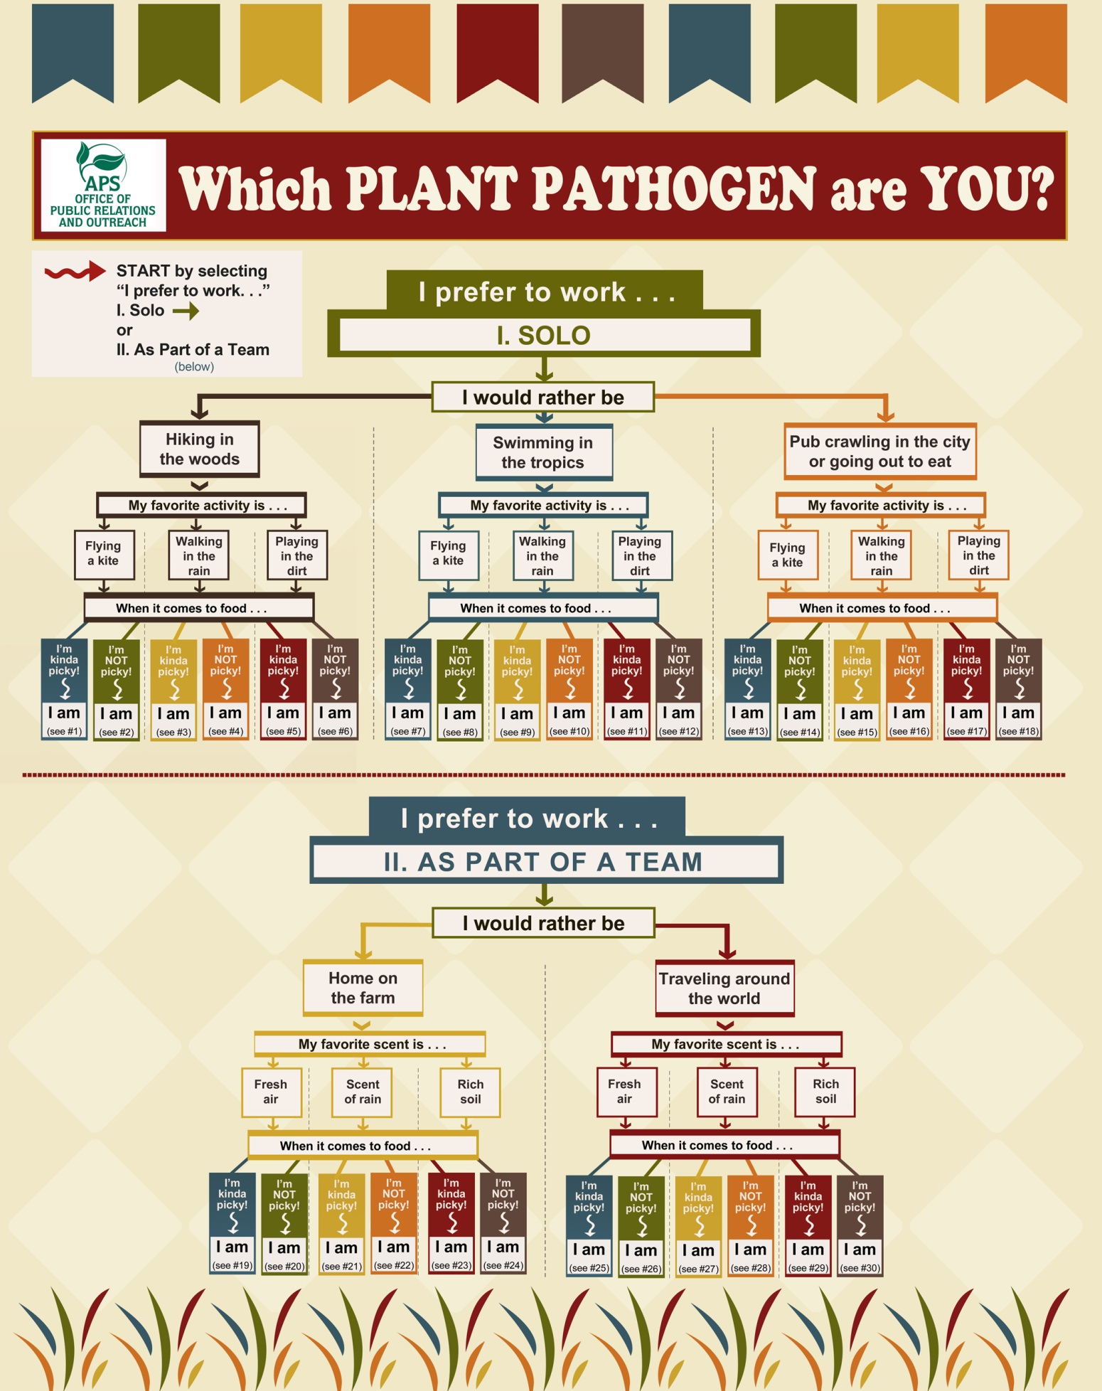

Table 1 of 5  I prefer to work | I would rather be | My favorite activity is | When it comes to food | (characteristics) | Suggested pathogen
Solo | Hiking in the woods | Flying a kite | I’m kinda picky | (-Forest pathogen  - Wind-disseminated  - Narrow host range) | #1 Cronartium ribicola  -White pine blister rust
 |  |  | I’m not picky | (- Forest pathogen  - Wind-disseminated  - Broad host range) | #2 Phythophthora ramorum  Sudden oak death
 |  | Walking in the rain | I’m kinda picky! | (- Forest pathogen  - Water dispersal or likes moisture  - Narrow host range) | #3 Cryphonectria parasitica  - chestnut blight
 |  |  | I’m not picky | (- Forest pathogen  - Water dispersal or likes moisture  - Broad host range) | #4 Phytophthora cinnamomi
 |  | Digging in the dirt | I’m kinda picky! | (- Forest pathogen  - Soil pathogen  - Narrow host range) | #5 Boletus edulis
 |  |  | I’m not picky | (- Forest pathogen  - Soil pathogen  - Broad host range) | #6 Armillaria

Table 2 of 5  I prefer to work | I would rather be | My favorite activity is | When it comes to food | (characteristics) | Suggested pathogen
Solo | Swimming in the tropics | Flying a kite | I’m kinda picky | (-Tropical/sub-trop pathogen  - Wind-disseminated or infects above-ground plant parts  - Narrow host range) | #7 Mycosphaerella fijiensis  Black sigatoka of banana
 |  |  | I’m not picky | (-Tropical/sub-trop pathogen  - Wind-disseminated or infects above-ground plant parts  - Broad host range) | #8 Lasiodiplodia theobromae  Rot and dieback
 |  | Walking in the rain | I’m kinda picky! | (-Tropical/sub-trop pathogen  - Water dispersal or likes moisture  - Narrow host range) | #9 Hemileia vastatrix  coffee rust
 |  |  | I’m not picky | (-Tropical/sub-trop pathogen  - Water dispersal or likes moisture  - Broad host range) | #10 Ralstonia solanacearum  Brown rot of potato, bacterial wilt of solanaceous plants & some ornamentals,  Moko disease of banana
 |  | Digging in the dirt | I’m kinda picky! | (-Tropical/sub-trop pathogen  - Soil pathogen  - Narrow host range) | #11 Heterodera spp  Cyst nematode
 |  |  | I’m not picky | (-Tropical/sub-trop pathogen  - Soil pathogen  - Broad host range) | #12 Meloidogyne  Root knot nematode

Table 3 of 5  I prefer to work | I would rather be | My favorite activity is | When it comes to food | (characteristics) | Suggested pathogen
Solo | Pub crawling or  Going out to eat  Hops, barley, wheat grape, pathogen etc. or a pathogen of food | Flying a kite | I’m kinda picky! | (Hops, barley, wheat grape, pathogen or a pathogen of food  - Wind-disseminated  - Narrow host range) | #13 Guignardia bidwellii  Black rot of grape
 |  |  | I’m NOT picky | (Hops, barley, wheat grape, pathogen or a pathogen of food  - Wind-disseminated  - Broad host range) | #14 Alternaria alternata  Spots, rots and blights
 |  | Walking in the rain | I’m kinda picky! | (Hops, barley, wheat grape, pathogen or a pathogen of food  - Water dispersal or likes moisture  - Narrow host range) | #15  Magnaporthe oryzae  Rice blast
 |  |  | I’m NOT picky | (Hops, barley, wheat grape, pathogen or a pathogen of food  - Water dispersal or likes moisture  - Broad host range) | #16 Botrytis cinerea  Gray bold, Botrytis bunch rot
 |  | Digging in the dirt | I’m kinda picky! | (Hops, barley, wheat grape, pathogen or a pathogen of food  - Soil pathogen  -Narrow host range) | #17 Phytophthora infestans  Late blight of potato, tomato
 |  |  | I’m NOT picky | (Hops, barley, wheat grape, pathogen or a pathogen of food  - Soil pathogen  - Broad host range) | #18 Agrobacterium tumefaciens

Table 4 of 5  I prefer to work | I would rather be | My favorite scent is | When it comes to food | (characteristics) | Suggested pathogen
As Part of a Team  (vectored diseases, disease complex, etc.) | Home on the farm | Fresh air | I’m kinda picky! | (-Agriculture pathogen,  - Above ground  - Narrow host range) | #19 - Maize lethal necrosis
 |  |  | I’m NOT picky | (-Agriculture pathogen,  - Above ground  - Broad host range) | #20 ‘Candidatus Phytoplasma asteris’  Aster yellows
 |  | The scent of rain | I’m kinda picky! | (-Agriculture pathogen,  - Water dispersal or likes moisture  - Narrow host range) | #21 Pantoea stewartii (Erwinia stewartii)  Stewart’s Wilt of corn
 |  |  | I’m NOT picky | (-Agriculture pathogen,  - Water dispersal or likes moisture  - Broad host range) | #22 Tomato spotted wilt virus (TSWV)
 |  | Rich soil | I’m kinda picky! | (-Agriculture pathogen,  - Soil pathogen  - Narrow host range) | #23 Sudden Death Syndrome of Soybean (Fusarium virguliforme and soybean cyst nematode Heterodera glycines)
 |  |  | I’m NOT picky | (-Agriculture pathogen,  - Soil pathogen  - Broad host range) | #24 Xiphinema americanum  Dagger nematode

Table 5 of 5.  I prefer to work | I would rather be | My favorite scent is | When it comes to food | (characteristics) | Suggested pathogens
As Part of a Team  (vectored diseases, disease complex, alternate hosts, etc.) | Traveling around the world  (worldwide, or spread globally) | Fresh air | I’m kinda picky! | (-Vector/or disease complex  - Worldwide  - Above ground  - Narrow host range) | #25 Puccinia graminis  Stem rust of wheat and barley
 |  |  | I’m NOT picky | (-Vector/or disease complex  - Worldwide  - Above ground / Wind-disseminated  - Broad host range) | #26 Raffaelea lauricola  Laurel wilt
 |  | The scent of rain | I’m kinda picky! | (-Vector/or disease complex  - Worldwide  - Water-dispersal or likes moisture  - Narrow host range) | #27  Sclerotinia  homoeocarpa  Dollar spot of turfgrass
 |  |  | I’m NOT picky | (-Vectored or a disease complex  - Worldwide  - Water-dispersal or likes moisture  - Broad host range) | #28 Xyllela fastidiosa
 |  | Rich soil | I’m kinda picky! | (-Vectored or a disease complex  - Worldwide  - Soil-disseminated  - Narrow host range) | #29 Fusarium oxysporum f. sp.  Fusarium wilt  Often part of root rot complex, and/or associated with nematodes, soil-borne, worldwide. Formae speciales generally limited host range.
 |  |  | I’m NOT picky | (-Vectored or a disease complex  - Worldwide  - Soil-disseminated  - Broad host range) | #30  Rhizoctonia solani  Rhizoctonia damping off, blight and rot  (common in root rot complexes, widespread, some AG with wide host range, many soil-borne)

